**IREVOLUTION A DATA-DRIVEN EXPLORATION OF APPLE’S IPHONE IMPACT IN INDIA**

**BHARATHI WOMEN’S COLLEGE**

**DEPARTMENT OF MATHEMATICS**

DONE BY:

**G. GIRIJA**

**P. SARITHA**

**M.YUVARANI**

**K. MAHALAKSHMI**

**MENTOR:** Mrs.S. KARPAGAVALLI

**INTRODUCTION**

**OVERVIEW:**

* **the use of smartphones is changed many in the world which have improved communication connected people and revolutionized many different business**
* **apple has a special to increase its market share and develop a significant presence in india thanks to the country’s large population and rising smartphone adoption.**
* **the iphone will perform a data driven investigation of the impact of the iphone in india**
* **each new iphone model unveiling generates excitement and anticipation among Indian buyers.**

PURPOSE:

* The main purpose of this project is to provide free skill development training for students
* This project helps the student identify their skills and give them training that will eventually enable them to find a better career
* Through this project we are know about what is empathy map and what are purpose of the empathy map and also the rain storming
* This project give’s an information that related to achieving the career goals.
* From the tableau it makes very useful for us to know how to use and how to make process for the students on courses and relevant information about industry specific skill offerings.

**PROBLEMDEFINITION AND DESIGH THINKING**

* Iphone user’s are facing various type of problem when they update to new iOS, transfer data from old to new iphone, jail break or launch any new app on their device
* The cost of the iphone as very expensive. the are poor or no WIFI connectivity. The iphone cannot be service easily. iphone apps are take up too much space.

**EMPATHY MAP**

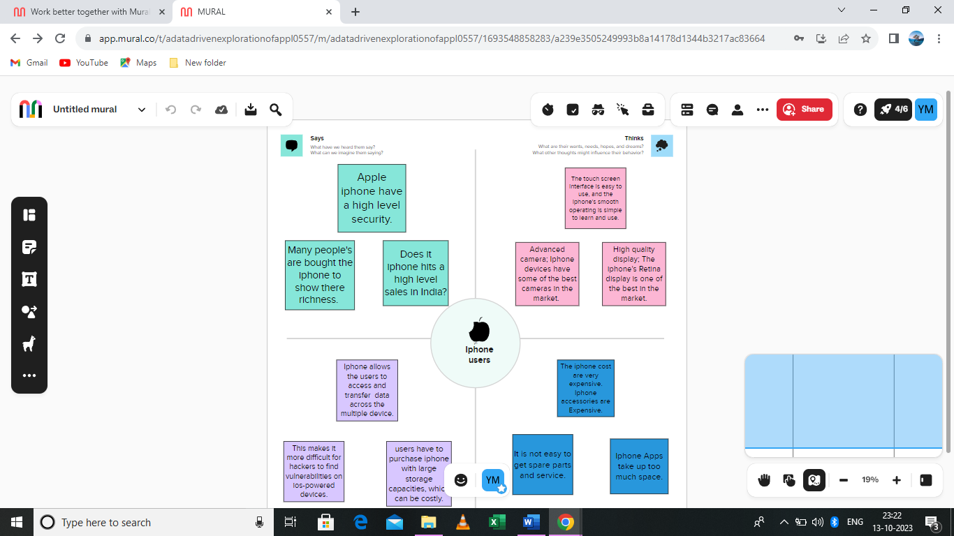

**BRAINSTROMING MAP**

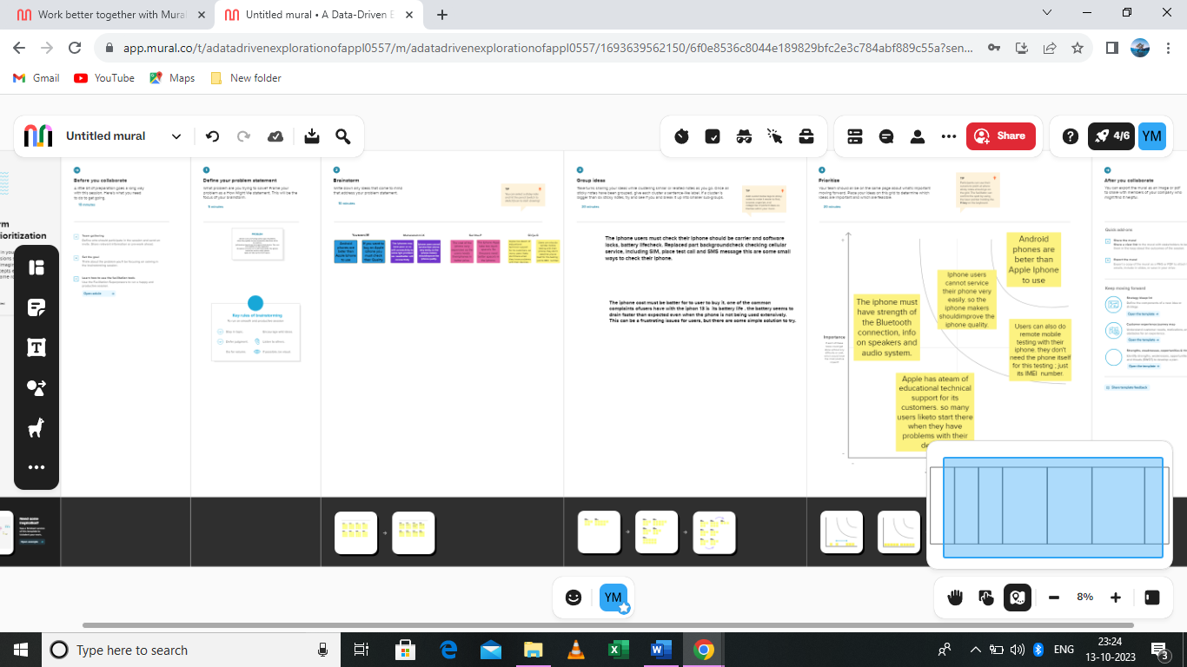

**RESULT**

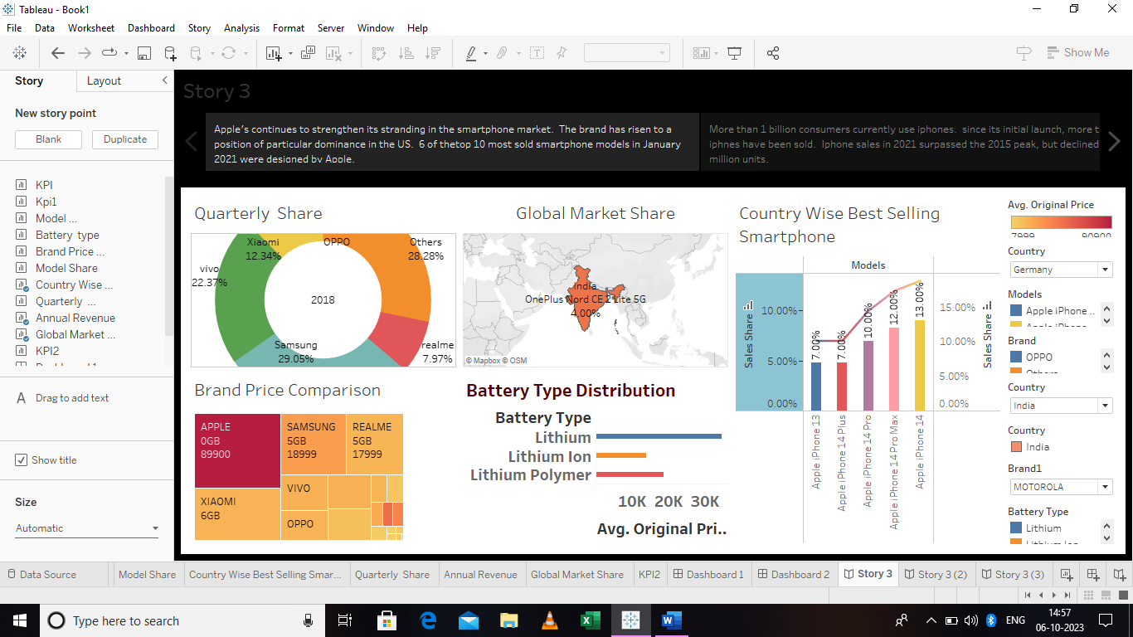

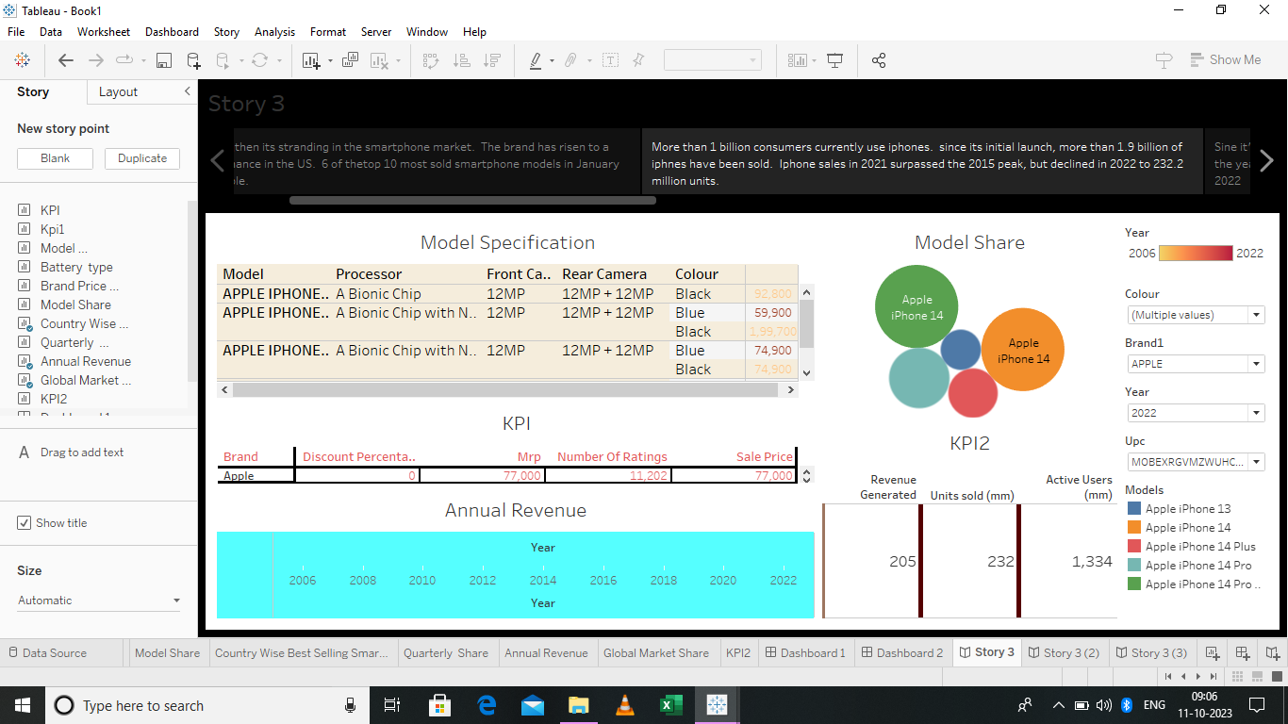

* Finally, the project from the above screenshots is the IREVOLUTION A DATA DRIVEN EXPLORATION OF APPLE IPHONE IMPACT IN INDIA [empathy map and brainstorming]and also the final screenshot is the story of the dashboard about apple iphone.
* This are all the final stage for this project

ADVANTAGES AND DISADVANTAGES

ADVANTAGES:

* User-Friendly Interface
* High Quality Display
* Advanced Camera
* Apps Ecosystem
* Seamless Integration With Other Apple Device

**DISADVANTAGES**

* Expensive
* Non-Removable Battery
* Limited Customization
* No Expandable Storage
* Frailty

**APPLICATION**

* A software application that

Runs under iOS which is the operating system that powers apple’s mobile device. in most cases any application that runs on an iphone also runs on an iPad and iPad touch. however, apps designed strictly for iPad. which have larger screens do not work on iphone and iPad.

The app store is a digital distribution platform which allows users to browse and download apps. Developed with apple iOS software development kit.

It is also capable of displaying e-books that incorporate multimedia books has also expanded to allow the purchase and listening of audiobooks through the apple iphone app. camera is a photo taking app introduced with the initial launch of the iphone with a new font and new Ui for controls. Web based application are responsive version of website built for working on mobile device

**CONCLUSION**

the main conclusion that can be drawn is we found to be the most interesting about apple is how they are very innovative and early adapters. Now ,they overall conclusion is from the empathy map we see that iphone users [feels, thinks about and say]and in the empathy map we are discussed about the problem statement and how to solve this problem about apple iphone .then we discussed about that tableau process for the apple iphone this make very useful for us develop our skills and he make a clarity for the future career goals. Then we discussed about the advantage and the disadvantage of apple iphone in india. It as revolutionized the way people communicate and access information. Apple is one of the biggest electronic gadgets industries in the world

**future scope:**

apple is one of the biggest companies is the smartphone world and has a very strong user base

which is ever growing and will keep doing so. The future of the iOS developers is going to be very bright and this market going to boom in coming years. However, one should keep in mind that in the market other then iOS developers there are other them to develop iOS apps, like cross platform app development using Xamarin and phone gap.

This will keep development only on the safer side, also different from the MOB, giving on edge in the competition. are developers are learning and enjoying work, then they can easily switch to other technologies and master them in lees time.